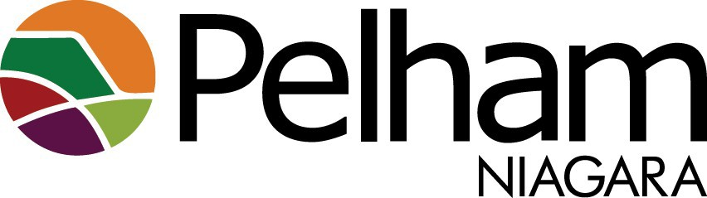

**Pelham Cultural Advisory Committee Meeting Agenda**

**1-2025**

**January 8, 2025**

**10:00 am**

**Kinsmen Room - Meridian Community Centre**

1. **Call to Order and Declaration of Quorum**
2. **Land Recognition Statement**

The Town of Pelham is situated on treaty land, steeped in the rich history of the First Nations such as the Hatiwendaronk, Haudenosaunee and the Anishinaabe, including the Mississaugas of the Credit First Nation. This territory is covered by the Upper Canada Treaties and is protected by the Dish With One Spoon Wampum Agreement. Today, many First Nations, Métis, and Inuit people from across Turtle Island live and work in Niagara. The Town of Pelham stands in solidarity with all Indigenous peoples, past and present, acknowledging that our high standard of living is a result of the resources and lasting friendship of Indigenous peoples.

1. **Approval of Agenda**
2. **Declaration of Pecuniary Interest and General Nature**
3. **Approval of Minutes**

Dec 11, 2024

1. **Year End Report to Council**
2. **Review of PCAC Goals and Priorities**
3. **Future Mural Theme list approval**
4. **Wrapped Electrical Boxes**
5. **PCAC Budget**
6. **Next Meeting**

February 12, 2024, at 10AM, Kinsmen Room, Meridian Community Centre

1. **Adjournment**